Roanoke County, Virginia

2010 Achievement Awards Submission

The Green Ridge Recreation Center
An Innovative Public-Private Partnership

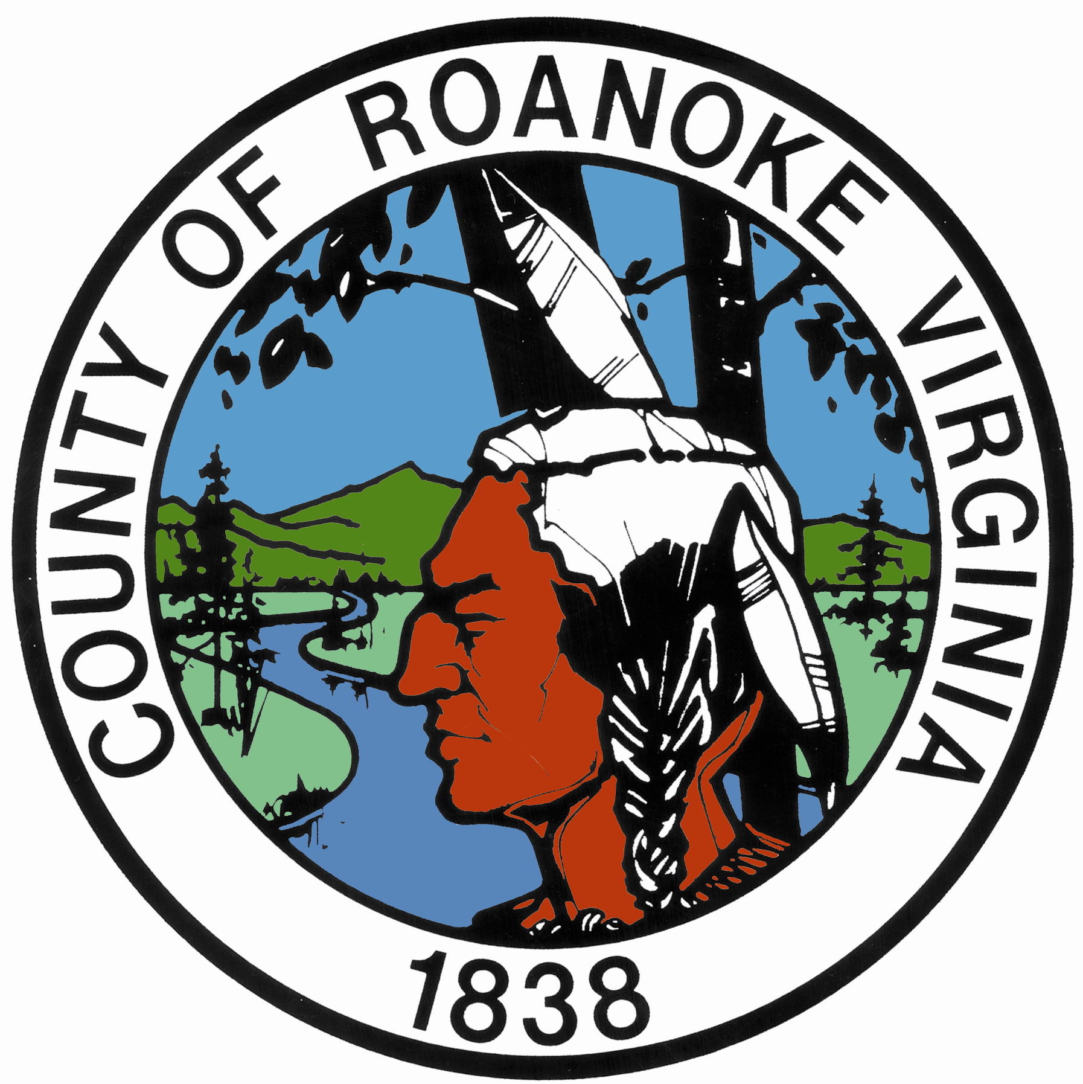

Presented to:
The Virginia Association of Counties
VACo

Prepared by: Jill Loope, Assistant Director
Roanoke County Economic Development Department

May 26, 2010

Introduction
Roanoke County is pleased to submit the following unique and innovative project for consideration of a Virginia Association of Counties (VACo) 2010 Achievement Award. The Green Ridge Recreation Center is a publicly-owned and developed 76,000 square foot state-of-the-art multi-generational recreation facility designed to serve the growing needs of the community and region. But the $30 million Green Ridge Center is not just another recreation center; it is a one-of-a-kind facility that will serve as a catalyst for new economic development opportunities throughout Roanoke County and the entire Roanoke Valley.
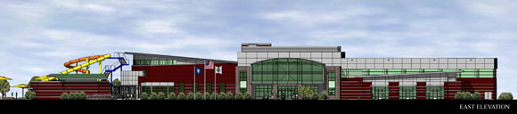
Located at the crossroads of Interstates 81 and 581, Green Ridge is distinctly positioned at the gateway to the Roanoke Valley. Its clever and thoughtful design, coupled with its business park setting strategically positions this facility to accommodate families, corporations, and visitors.
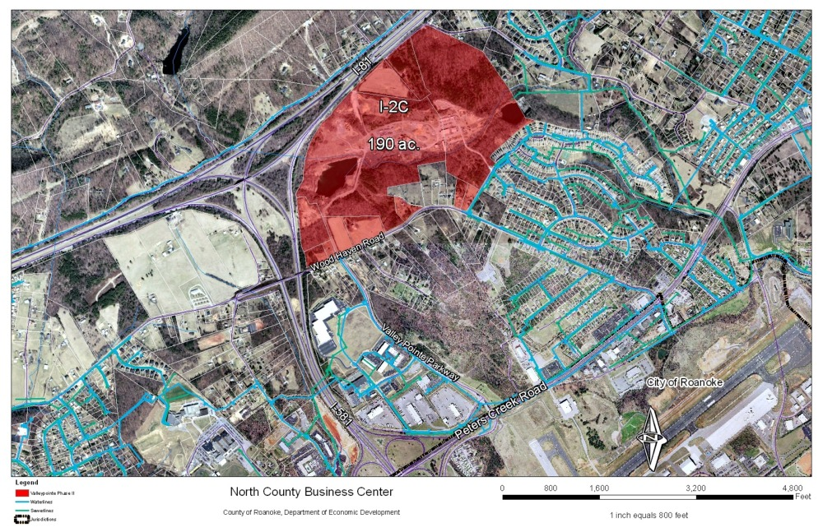

Innovativeness and Public/Private Partnership

Green Ridge is the first multi-generational recreation center in the Roanoke Valley. A multi-generational recreation center (also called a multi-gen center) is a recreational community center designed to serve all age groups in a community. Although mainly indoor facilities, many of these centers also have outdoor features such as walking trails and mini water parks. Multi-gen centers offer programs and services for people with a wide range of ages, abilities, and income.
The amenities in successful multi-gen centers are those most desired by the community they serve. Multi-gen centers often will feature meeting rooms and classrooms, fun aquatics features, teen and senior program space, indoor gymnasiums, jogging tracks and fitness areas. The facilities and programs featured in a multi-gen center are designed to promote active lifestyles that support community fitness in an affordable way.
Roanoke County’s Green Ridge Center was customized to serve the needs of Roanoke County citizens and businesses, and incorporated many of these concepts in its design including a double gymnasium with basketball courts, a fitness center, two aerobics rooms, three multi-purpose program rooms, and an indoor aquatics center with an adjoining party room. In addition, the Center has a 20,000-square-foot mini water park which includes an outdoor leisure pool with large slides and a lazy river dubbed “Splash Valley.” The building also features an indoor walking track that offers sweeping vistas of the beautiful Blue Ridge Mountains.
This facility was strategically positioned to serve as the catalyst and anchor for the 190- acre North County Business Park, to be developed in the near future. Further, this North County location serves a large number businesses located in the nearby ValleyPointe Corporate Center (over 25 businesses employing up to 400 people) and other high profile corporations such as Optical Cable Corporation, Pixel Optics, the Kroger Corporation, and Advance Auto Parts, a fortune 500 company headquartered in the Roanoke Valley.
Roanoke County has for many years envisioned the creation of a business park at this strategic location and has entered into a public-private partnership with the owners/developers of the property, English Construction (who teamed with Moseley Architects to become First Choice Public Private Partners), to make this vision a reality. Further, the developer utilized an innovative and non-traditional approach called the Public-Private Education Facilities and Infrastructure Act (PPEA) to submit an unsolicited proposal to build the center. The PPEA permits a private company to initiate a proposal to build a public facility. This streamlines the normal construction timetable by replacing the competitive bidding with a process of “competitive negotiation,” in which different companies can submit proposals for a complete project, including the facility design.
This process and proposal from First Choice was eventually accepted by the Roanoke County Board of Supervisors. To date, First Choice has worked with the County to prepare an access road and other infrastructure improvements to the Green Ridge facility, which will also serve as the entrance to the new North County Business Park. Initially conceived as the Roanoke International Office and Research Park, the following represents an initial Master Plan for the development indicating the potential of the Park for future development.
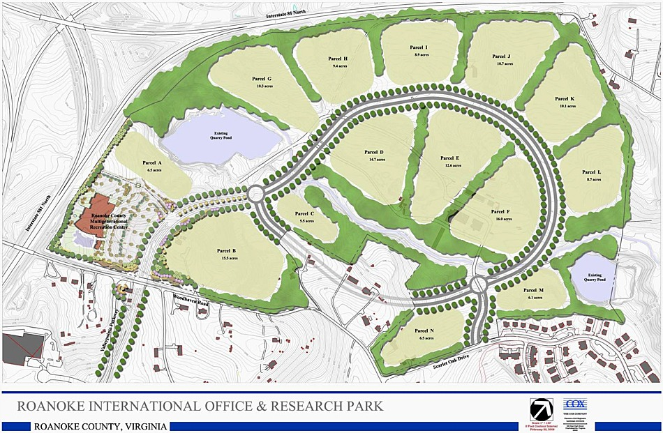 Denotes Green Ridge Recreation Center location on map
Both English Construction and Roanoke County have for many years shared the goal of constructing a business park at this interstate location, but lacked a significant anchor for the project. The multigenerational recreation center will serve as that anchor and entrance to the new 190-acres business campus designed to attract upscale corporations to Roanoke County.
The new multi-generational facility was dedicated in December 2009 and Splash Valley Water Park opened in May. The North County Business park project will occur in the future.

Transferability

The PPEA method of developing the Green Ridge Recreation Center can be utilized by any Virginia community seeking to build public facilities. This results in cost and time savings to the community, in addition to allowing the locality maximum input into a quality project.
Roanoke County citizens, businesses, and government have all participated in supporting this innovative project, which can be easily replicated in any community. Early public input into the process to determine community needs and desires through public meetings, surveying, and interviews assisted the County with determining the overall design and location for the facility.

Community Commitment and Leverage

Roanoke County recognized the need for a new, multi-use recreation center as demand for recreational opportunities, organized leisure activities, senior and youth programs, and meeting space increased in the County over the past decade. In 2006, Roanoke County surveyed citizens about their recreational needs as part of the Parks, Recreation and Tourism year-long master planning process. Parks, Recreation and Tourism also conducted a number of public meetings to discuss the results of the master planning process with County residents. The multi-gen center concept brings together many of the community’s top-rated recreational needs as identified by the master plan. The entire project has been a model community development initiative from its inception.
Although the County financed the $30 million project through a bond issue along with other capital projects, operating costs will be paid for by affordable user fees as noted in the attached documents. Roanoke County residents and businesses pay a lower rate for the services than residents from other communities who use the center. The County is also forming partnerships with local educational and medical institutions that could be mutually beneficial. Obviously, given the significant community investment in the project and jobs created to run the facility, Roanoke County has a deep rooted commitment to the ongoing success of this project. The use of the PPEA helped the County and the Developer to achieve greater impact for the project through streamlining the construction process.

Measured objectives

The benefits of the Green Ridge Recreation Center have been significant in that the facility has created 120 part-time and 10 full-time positions to date. Plans for the future include the creation of an additional 30 new positions with the opening of Splash Valley.
This modern, multi-gen center will enhance Roanoke County’s reputation as a community that supports high-quality recreation and healthy lifestyles. Here are just a few benefits Roanoke County will see as a result of a multi-gen center …
- A multi-gen center will help attract and keep young professionals in the Roanoke Valley.
- It will provide healthy leisure activities for youth.
- It will provide active seniors with social and recreational options.
- It will provide a quality of life feature to help grow new businesses essential for future economic prosperity.
- A multi-gen center will be a signature facility for Roanoke County that will serve as a public meeting place for businesses as well as citizens.
- Day visits by citizens from nearby communities will strengthen Roanoke County as a regional leisure destination for family attractions and events.
- A multi-gen center will enhance Roanoke County’s position as a host of regional and national sporting events and athletic tournaments, bringing tourism dollars into the community.
Secondary Benefits
While the Green Ridge Center is a quality of life amenity for Roanoke County, it also serves as an economic development and incentive tool as the County works to attract new businesses to the community. It is also an Existing Business Retention tool as companies have continually expressed interest in the new center.
Businesses today are seeking amenities to attract and retain valuable employees. Public facilities, such as the Green Ridge Recreation Center, can offer a variety of these amenities in one location including day care services, family activities, and recreational opportunities, all which promote a balanced and healthy lifestyle and meet the needs of the business community. The Center also provides alternative meeting spaces for the community.
As previously mentioned, the Green Ridge Center will also serve as the catalyst for the development of the 190-acre North County Business Park in the future and will assist with the attraction of new businesses to the Roanoke Valley.

Summary
In conclusion, the Green Ridge Center is a state-of-the-art facility representing a significant capital investment by Roanoke County. The completion of the Center demonstrates leadership and a commitment by Roanoke County to implement a bold vision for the future of the community.
Not only has the center responded to the needs and demands of citizens for alternative recreation opportunities, it is also serving as an attractive business recruitment and retention tool. Local economic development strategies have evolved from being heavily focused on industrial recruitment to embracing a community development model that includes providing amenities that add value to all residents of the community as well as corporate interests. This project accomplishes that goal.
Additionally, the Green Ridge project utilized a creative public/private partnership and the PPEA process, which allowed the County to streamline the construction process. The Green Ridge Center is a model project that can be easily replicated in other communities across Virginia.

