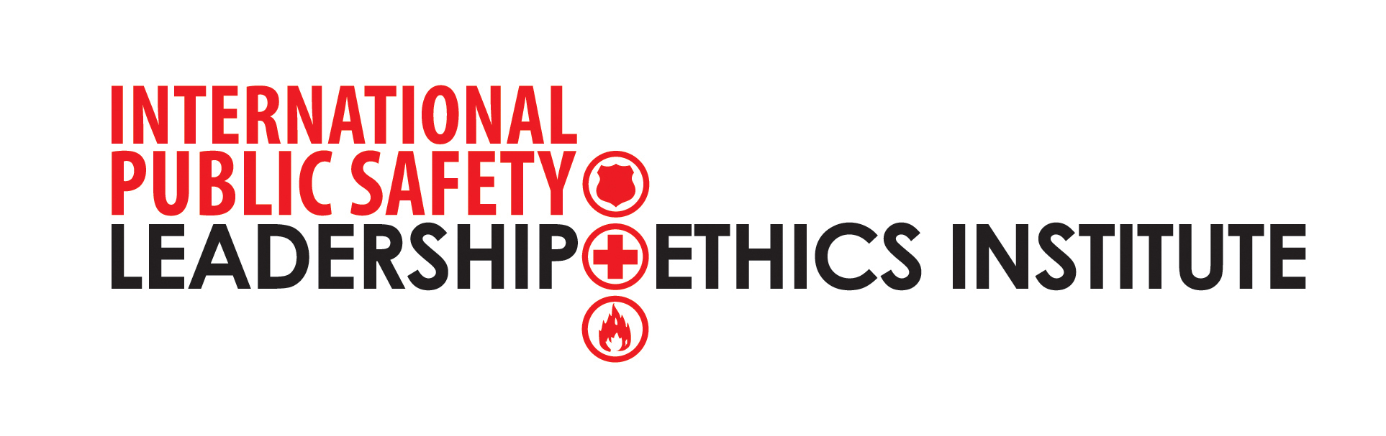

The Office of Executive Management/Training & Development Program is seeking qualified PWC supervisors/managers/executives willing to receive 160-hrs of instruction in supervisory and pre-supervisory course work followed by 40-hours of Train-the-Trainer for the four courses in the International Public Safety Leadership and Ethics Institute (IPSLEI) curriculum. This instruction would occur during FY10.

Interested and qualified “trainers” should submit an electronic version of their resume to Sarah Ray Pickard at sray@pwcgov.org by COB August 19th, 2009. Please include organizational, educational, supervisory, and training experience.

This program has been endorsed by California Police Chiefs Association, the Commission on Correctional Peace Officers’ Standards and Training (CPOST), the California Sheriffs Association, the U.S. Fire Administration – National Fire Academy, the City of Alexandria Fire Department, and the PWC Office of Executive Management’s Training & Development Program.

The 4-40 hour courses must be taken consecutively and have been adopted by OEM/T&D to be the PWC University curriculum for pre- and supervisory training. Each course is extensive and trained course facilitators will engage PWC employees through adult learning techniques that energize and enlighten.

Implementation of the IPSLEI is supported through facilitators certified in the content and teaching methodologies used in the program. IPSLEI uses a forty hour facilitator certification program in partnership with the Phi Theta Kappa Leadership Development Program Facilitator Certification Course. The following are the International Public Safety Leadership and Ethics Institute facilitator qualifications:
- Ten (10) years organizational experience with at least two (2) years at the supervisory/managerial level
- Bachelors Degree, Masters Preferred. Individuals without degrees but with exceptional organizational experience and non-traditional educational credentials may be considered as meeting the educational qualification. This will be approved on a case-by-case basis.
- Five (5) years presenting in adult facilitated learning method.
- College, university, or organizational sponsorship/recommendation.
Interested and qualified trainers should submit an electronic version of their resume to sray@pwcgov.org by COB August 19th, 2009. Please include organizational, educational, supervisory, and training experience.

The four-40-hr course descriptions and class dates follow:

Course 1: Developing a Personal Philosophy of Leadership
Course Description: This course will introduce the IPSLEI, and provide the participant with a deeper understanding of self as it relates to leadership philosophies, knowledge, skills, and abilities. Each participant will study and explore their core values, ethics, decision making, and begin to develop a personal philosophy of leadership. Through course presentations, dialogue, and learning activities, the participant will identify leadership roles in the community to include self, family, professional, and social. In addition, they will be able to define the difference between leadership and management. The participant will complete self assessments to gain insights into their personal leadership style and characteristics and participate in video and written case studies to further explore their understanding of leadership. [Dates: Sept. 24, (Sept. 28 or 30 – one of these is optional), Oct 1, 8 and 22 from 8:30 a.m. – 5:00 p.m. daily]

Course 2: Leading Others
Course Description: This course is the second in the continuing series of the IPSLEI. This course is designed to provide the participant with the knowledge, skills, and abilities to effectively lead others. The participant will explore various roles of leadership as they relate to being a team builder, delegator, conflict resolution facilitator, coach, and mentor. The participant will also gain an understanding of communication processes, empowerment, and leading in a diverse environment. The participant will explore various theories of leadership, including situation leadership, transformational leadership, and servant leadership. Case studies, video analyses, and other interactive learning processes will be used to explore the dynamic relationship between leaders and followers. [Dates Oct. 29 (Nov. 2 or 4 – one of these is optional), Nov. 5, 19, and Dec 17 from 8:30 a.m. – 5:00 p.m. daily]

Course 3: Organizational Leadership
Course Description: This course is the third in the continuing series of the IPSLEI. The participant will explore the leadership process and the leader-follower relationship within organizational settings. Additionally, the influence of organizational culture, values, and contemporary societal issues on leadership effectiveness will be explores, as well as the concepts of learning organizations, organizational health, defenses, and change. Participants will also explore how a leader moves an organization from vision to action. Case studies, video analyses, selected readings, and group activities will be used to help the participant further understand the theories and principles of organizational leadership. [Dates in 2010 Jan – May TBD]

Course 4: Ethics and the Challenge of Leadership
Course Description: This is the final course in the series of the IPSLEI. In this course, the participant will correlate personal core values and characteristics to ethical decisions and behaviors. In addition, the participant will explore ethical and principle-centered leadership, including ethical systems, ethical dilemmas, and ethical decision-making models. The participant will also examine challenges and develop strategies for leading in public organizations service diverse and dynamic communities. The participant will use a variety of learning modalities including case studies, video analyses, and critical thinking scenarios to explore ethics and the challenges of leadership. [Dates in 2010 Jan – May TBD]


