2010 VACo Achievement Awards

Loudoun Homeless Services Center
Loudoun County, Virginia
May 25, 2010

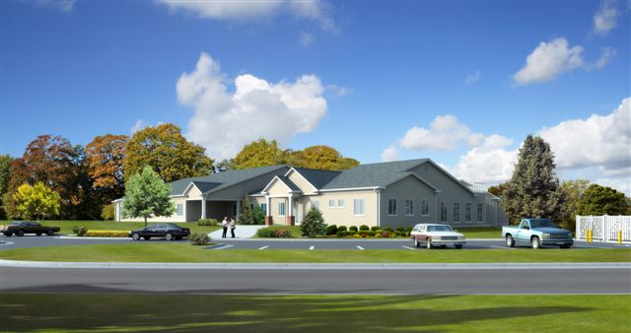

Overview
In 2007, Loudoun County was faced with multiple challenges that were impacting the service delivery to the homeless population. These challenges included (1) future closure of current homeless shelter for unsanitary conditions due to an expanding landfill; (2) Increased need for more shelter beds due to rapid population growth; (3) No shelter beds available in the community for single men; (4) A Cold Weather shelter was temporarily opened in an inconvenient leased rural location with high transportation costs to the county; and (5) the County’s Drop-In center was in a temporarily leased space and needed a permanent home.
County agencies, federal, state and local funding sources collaborated to develop a program to design and construct an 8500 square foot expansion to the existing Transitional Housing facility to satisfy the five homeless issues listed above while providing a better location, better service, safer facility, and better case management to clients. The result was a state of the art, LEED certified, building with more beds consolidating four facilities under one roof. The Transitional Housing Facility was on an underutilized 3 acre hillside parcel within close proximity to the public bus route. The resourceful and collaborative efforts of the planning design team saw the untapped opportunity of the parcel. In addition, the creative architectural design lent perfectly with the solution, and achieved many cost efficiencies. The new facility combines the Emergency Homeless shelter which provides 45 beds for single men, women and families (an increase of 21beds from previous shelter); the Cold Weather Shelter which provides overflow beds for single women and men during the winter months to prevent hypothermia and related illness; the Drop-in center which provides laundry and shower facilities, food and case management to homeless individuals 40 hours per week and the Transitional Housing program which provides 8 apartments for families and single females for up to 24 months.
Loudoun County, Virginia is one of the fastest growing counties in the nation. During 2007, Loudoun County was faced with five different challenges related to the homeless needs within the community. The challenges were as follows:
- Expanding the County Sanitary Landfill would leave the three existing family homeless shelters (24 beds) with unsafe/unsanitary conditions and potentially contaminated water by 2009. A long-term permanent solution was needed.
- More emergency shelter beds were needed due to population growth.
- The faith-based men’s shelter was closed in late 2006, forcing homeless men to live in their cars, the woods, in tents or leave the area. Most were employed but found it difficult to keep a job without a place to stay. The County needed an emergency shelter to house single men.
- Due to the shortage of emergency shelter beds for single women and single men, a Cold Weather Shelter (CWS) was temporarily opened in a leased building to prevent hypothermia and illness during the winter months. The rented space was a short-term solution at an inconvenient (rural) location. The County provided transportation to and from the location. This became a very expensive program. A long term permanent solution was needed.
- A temporary leased day-time drop-in shelter was also serving 400 visits a month. A long term permanent solution was needed for this program as well.
Innovation: This project meets the awards criteria of Innovation.
A new homeless shelter was in the County’s Capital Improvement Project to begin design in FY 2009, however, when it became apparent that the landfill was on track with their expansion and that the expansion would create unsafe conditions at the current facility, the Board moved the project to an earlier year. This vote occurred in March of 2007. During this time frame the other issues addressed earlier surfaced. A non-profit in the community ran both a men’s shelter and a cold weather shelter during the winter months, however, during the last few months in 2006, they terminated both of these services. In addition, the same non-profit operated the Drop-in Center and they announced that they would soon be terminating that service as well. The Board of Supervisors saw the immediate need for a drop-in center as well as a cold weather shelter, therefore, they voted to assign the management and operation of these two programs to the Department of Family Services. The timing for this decision came around the same time that the economy experienced a downturn. Even though new programs were added to the Department, no new funds were available to manage these programs. Temporary arrangements were made to operate the Cold Weather Shelter and the Drop-in center in leased spaces.
Concurrently, the design team (made up of program staff, architects, engineers, non-profit providers, information technology staff, etc.) for the new homeless shelter began meeting to finalize a building site and to begin the design. When looking at the various challenges the County was facing with the homeless needs and decreasing revenues. it was decided to build the new facility onto an existing homeless program and incorporate all homeless programs operated by the County under one roof. This decision was the beginning of the innovative solution that came to fruition in September of 2009.
County agencies, federal, state and local funding sources collaborated to develop a program to design and construct an 8500 square foot addition to the existing Transitional Housing Facility to satisfy the above five challenges; providing a better location, better service, safer facility, and better case management to clients. The result was a state of the art, first Loudoun County Government LEED certified, energy efficient building that consolidated four facilities into one. The Transitional Housing Facility was on an underutilized three acre hillside parcel with close proximity to a public bus route. The resourceful and collaborative efforts of the design team saw the untapped opportunity of the parcel. In addition, the creative architectural design lent itself perfectly to the consolidated solution and achieved many cost efficiencies. The new facility provides 32 beds for families and single women plus an additional 13 beds for single men.
Financing: The total cost of the Emergency Homeless Shelter project was $2.3 million. County tax dollars were the primary source of funding for this project and resulted from a careful review of many competing projects typical of a county undergoing rapid population growth (schools, public facilities, public services, and public safety). The urgency of the Emergency Homeless Shelter came as a result of an expanding landfill within close proximity to the existing family homeless shelters coupled with a need for additional bed space, the need for a single men’s shelter, and a permanent location for the Cold Weather Shelter and the Drop-in Center, both of which were operating in separate temporary leased spaces.
$2.1 million of County funds was leveraged with $200,000 state funds, $250,000 Community Development Block funds (Federal dollars) to satisfy the impending displacement of the existing shelter. When American Recovery Act funds became available in the spring of 2009, plans were made to include solar panels to enhance the “greenness” and sustainability of an already well-designed, energy efficient and well insulated, low maintenance building. The solar panels provide 13.49% of the Kilowatt hours needed to operate the 8500 square foot addition generating a savings over $2,600 per year. Ongoing operating funds will be locally funded. One of the major goals/objectives of this project was to ensure that operating costs be as efficient as creatively possible, and that operating savings be built-in. The consolidation of several aging, poorly insulated, high maintenance facilities into the new facility afforded the county economies not only in manning the facility, but in overall facility care/maintenance as well. The new Emergency Homeless shelter is an 8500 square foot expansion of an existing Transitional Housing Facility. It shares the same real estate footprint, the same roof, the same common facilities, parking, playground, group meeting spaces, and provides flexibility for the expansion/contraction as the need arises. It is aesthetically pleasing and provides a safe and comfortable temporary residence for our homeless population. It provides efficient/effective program delivery, best use of manpower, all in a convenient location with public transportation access.
A difficult economy forces communities to be more innovative and creative. The innovative cost savings come from consolidating four existing inefficient service delivery locations into one well-designed shelter. The aging facilities were high maintenance, with failing septic, poor insulation, energy inefficiency and an unsafe environment resulting from the encroaching landfill. The addition of solar panels using only $44,000 of CDBG-R funds will result in long-term energy savings and contribute to a smaller carbon-footprint, saving more than $195,000 in renewable energy costs over the 75 year expected life of the facility. A low maintenance, safer environment for the clients, coupled with a holistic team approach by staff provides better case management to identify issues, problems and solutions to break the homeless cycle. Additional costs savings come from the physical location of the new facility and its ready access to public bus transportation. Two of the prior facilities (Family Shelter and Cold Weather Shelter) were located in rural areas of the County and required that the County contract for bus transportation to and from various in-town locations. The new facility is centrally located with ready access to services and transportation. By opening the new facility, transportation costs savings have amounted to approximately $25,000 per year. The space for the Cold Weather Shelter and the space for the Drop-in Center were leased. By consolidating these programs under one roof, the County realized another savings of about $55,000 per year. Although the consolidating programs and terminating leases were the biggest cost savings, there were other efficiencies that were found as well. The operation of the new facility is operated under contract with Volunteers of American, a non-profit. The four program areas are all included under one contract with this organization. Since all programs are on the same site, they have had efficiencies in their insurance costs, and the ability to share staff amongst the programs. They have also reduced the need for large vans for transporting the clients.
Program Results: The results of this program include the following:
- A state of the art, first Loudoun County Government LEED certified, energy efficient building which serves multiple needs in a single facility and provides 33% more beds for families and 100% more beds for single men. Since the facility houses several homeless programs the facility was named Loudoun Homeless Services Center.
- This project provides economies and efficiencies of scale. Savings in program delivery (staff can be used to serve multiple programs at the same facility), savings in building lease/maintenance (one building vs. four), savings in energy efficiencies (new building is LEEDS certified and has received awards for its efficiency).
- The site selected lends perfectly to the solution. The site is located on a hillside. The single men’s shelter is on the ground floor. The family and women’s shelter is on the first floor on the same level as the Transitional Shelter and shares some of the group facilities. The new facility has a courtyard where families can watch their children at play and a kid-friendly playground with room to exercise, explore and grow. The site is on a public bus route with access to libraries, shopping, schools, jobs, public services, religious, and social activities.
- The solution results from cross-functional input. Stakeholders focused on specific, yet related and intertwined goals. It is a win-win for all, the County, the various program managers, and most importantly, the homeless community.
- The solution made the best use of funds (local tax dollars, state shelter expansion funds, CDBG funds for building and design, and CDBG-R funds for solar panels/renewable energy) with the least long-term operating costs. The solution is green, environmentally friendly and efficient. It is sustainable and renewable.
- From more than 2,500 nominated projects, the new Loudoun County Emergency Homeless Shelter was selected as a Green Building of America Award winning projects and will be featured in the magazine Real Estate and Construction Review – Green Success Stories Edition. It will be credited as a leader in the principles of green design and sustainable strategies.
- This project was also selected by the National Association for County Community and Economic Development (NACCED) for its 2009 Award of Excellence in the category of Innovation.
The actual results were more than initially hoped for thanks to the cooperation, creativity and collaboration of a cross-functional planning and design team that embraced, intertwined, yet sometimes, had separate goals while working on a fast track pace to find an innovative solution for many challenges. The solution serves an expanding community and does so with no additional costs over the long term. The common goal to provide better service to clients, a better location, and long term efficiencies in operation and program delivery has been a huge success.

Attachment 1
BEFORE
The facilities below housed 3 of the Department of Family Services vital programs. These facilities were temporary, expensive to access and maintain, and were inadequate for our growing population. These 3 programs, plus additional beds will be housed in the new Homeless Services Center.
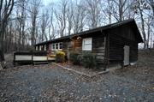
The leased facility that housed the Cold Weather Shelter which was located in a very rural area.
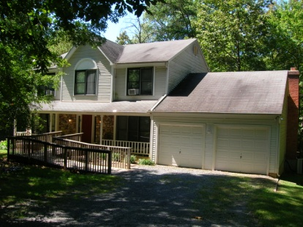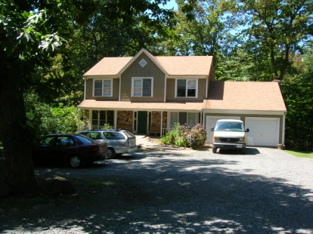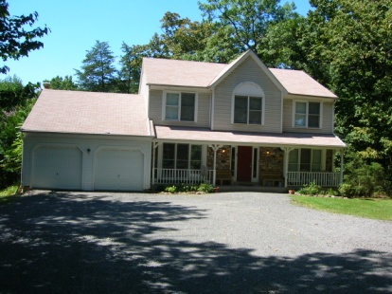
Old Family Shelters located in a rural area, unsafe due to expanding landfill.

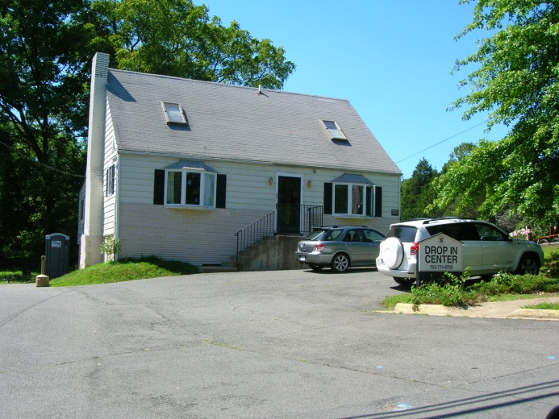 The leased facility that housed the Drop-In Center.

Attachment 2
A F T E R
New and Improved Loudoun Homeless Services Center
Opened September 2009

